Sensitivity analysis of Savannakhet model

# Introduction

# Univariate sensitivity analysis

Out of total 60 parameters of the model, 37 user input-able parameters are tested for sensitivity on incidence (Fig. 1) and prevalence (Fig. 2). Each parameter was take a varied value (either a lower value or a higher value, the values chosen can be seen in Date file 1 and the results in Data file 2).



Fig. 1: Sensitivity of user input parameters on incidence at the end of simulation (year 2023)

Both incidence and prevalence are most sensitive to **bh_max (# of mosquito bites/human/night), effITN (Effect of LLIN) and case importation parameters (muU, muA, muC).**

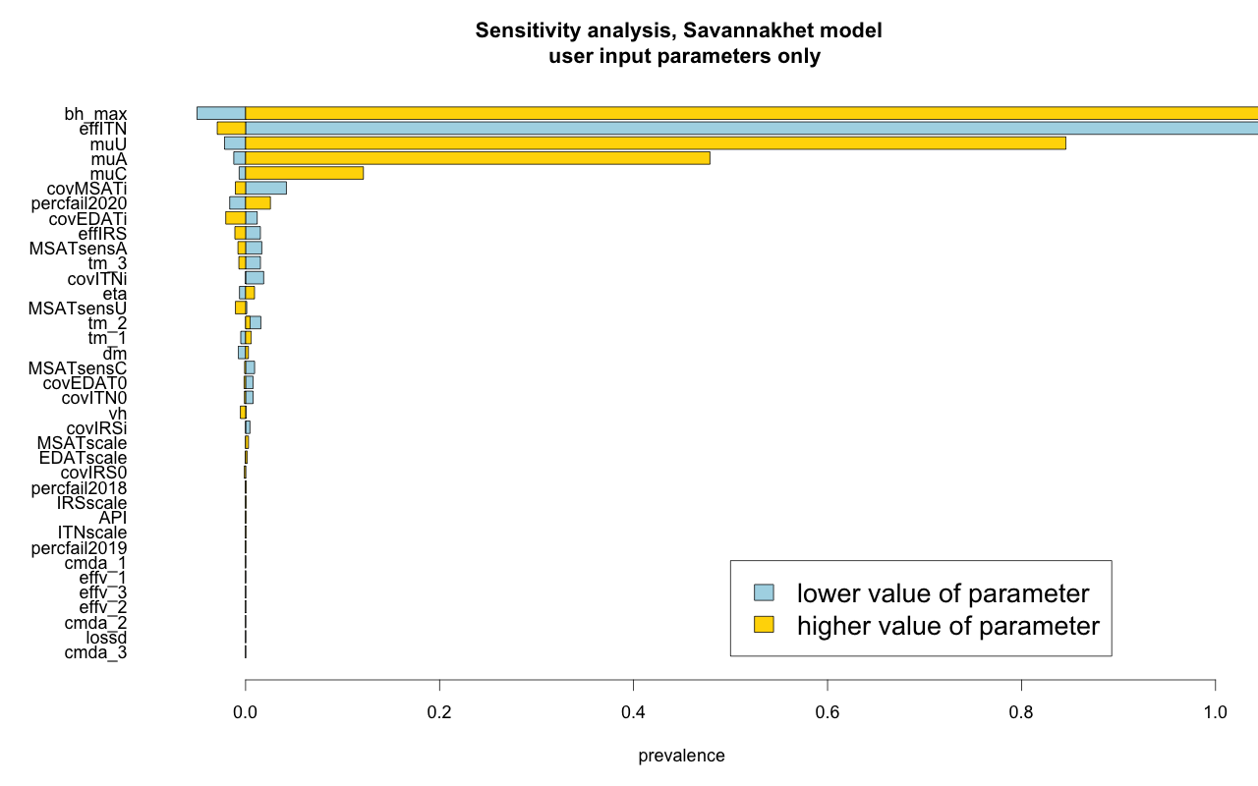

Fig 2. Sensitivity of user input parameters on prevalence at the end of simulation (year 2023)

# Probabilistic sensitivity analysis

We generated 10000 sets of baseline parameter sets from random uniform distributions. Among these, we chose 102 baseline parameter sets that could approximate the baseline malaria status of Savannakhet. We generated 100 intervention parameter sets to pair up with those 102 baseline parameter sets. The timing of MVDA rounds and the effects of vaccine which are incremental over time, are generated based on the random proportions to the lattermost (biggest) value. All other intervention parameters are sampled from a uniform distribution. Interventions are sequentially turned on for each 10200 parameter sets (Data file 3). The mentioned steps can be seen at Fig. 3.

Fig. 3: Steps taken for the probabilistic sensitivity analysis.

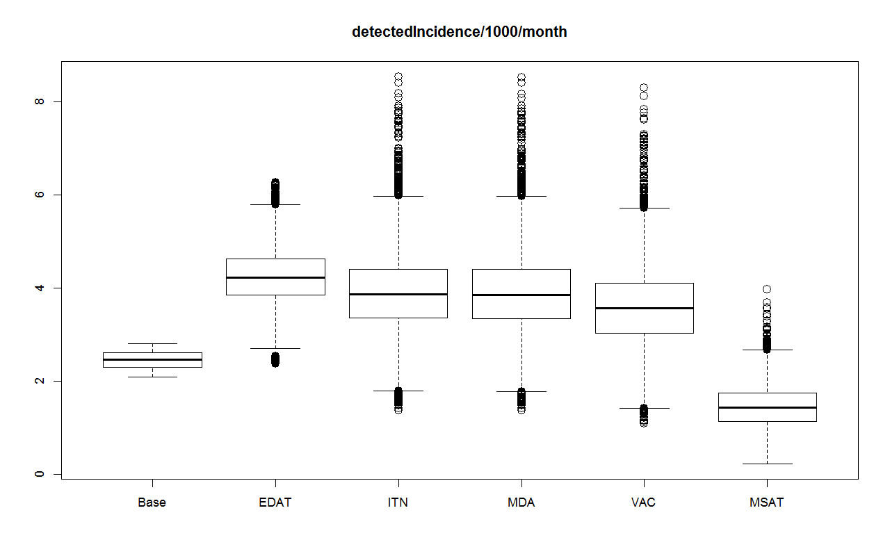

Fig. 4: Sequential effect of interventions on incidence (incidence/1000/month)

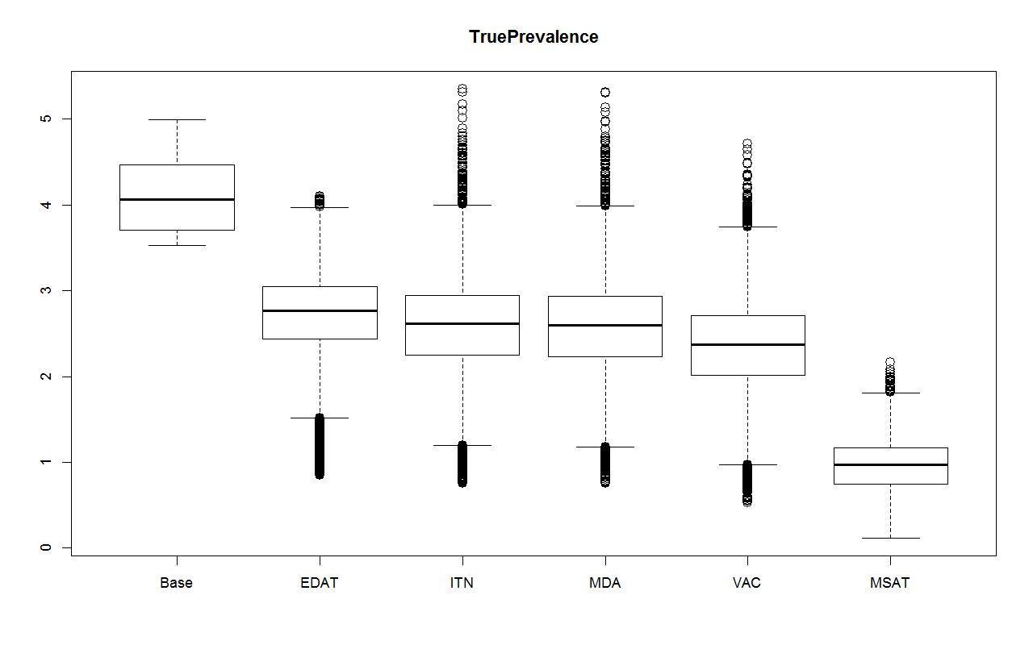

Fig. 5: Sequential effect of interventions on prevalence

Fig. 5: Additional effect provided by vaccine